Contract Structure

Creation of elements

WS can be created independently. By “created” we mean that the WS created will appear in the combox of WS. That’s all.
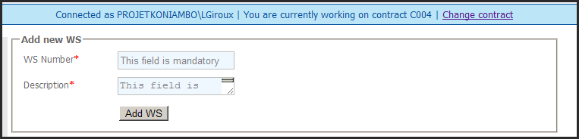

Same for WP.
Same for CWP.

At this time, all these elements are independent. We have a list of WS, a list of WP and a list of CWP.

Associtation of elements created

Now we want to link these independent elements in order to make the structure of the contract.
The rules we define are the following:
- A WS must be compose with at least one WP
- A WP must be compose with at least one CWP

So what we do is adding a CWP to the structure. This CWP must be linked to a WP and a WS. We also have to provide an allocated amout of hours for this CWP/WP/WS association .
See screen below:
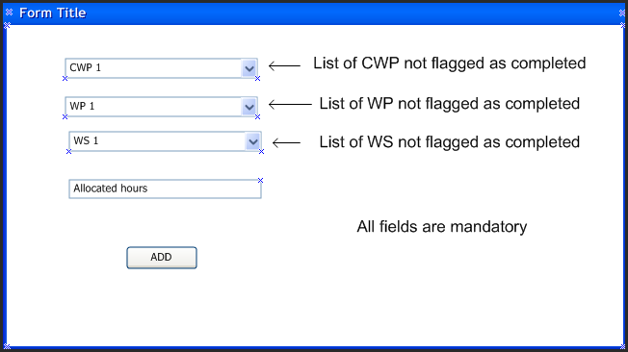

As a result of all the addition of CWP to the structure, the structure will look at the end as below:

